Scan the QR code to access the application form.

For Further information please see our website:

penistonestjohns.co.uk



Or please contact the school office.

**Infant Site**: Contact: Mrs Lindley  
Chapelfield Lane  
Penistone  
S36 6FS

Tel: 01226 762496 ext 2

**Junior Site**: Contact: Mrs Holley  
High Street  
Penistone  
S36 6BS

Tel: 01226 762496 ext 1

Email: [office@penistonestjohns.org](mailto:office@penistonestjohns.org)

Pupil Premium Lead

Mrs S Dougal

## Can I apply for free school meals?

You will qualify for free school meals if you receive:

* Income Support
* Income-based Jobseekers Allowance
* Income-related Employment and Support Allowance
* Child Tax Credit with an annual income of less than £16,190, provided you are not receiving Working Tax Credit
* The ‘guaranteed’ element of the State Pension Credit
* Working Tax Credit run-on (paid for four weeks after you stop qualifying for Working Tax Credit)
* Universal Credit with an annual net earned income threshold of less than £7,400
* Support under part six of the Immigration and Asylum Act 1999



Top of Form

Bottom of Form

**Free school meals**

You could save up to £400 a year with free school meals for your child. School meals can also save you time and provide peace of mind that your child is enjoying a healthy, fresh, and nutritious meal at lunchtime. Some of the benefits are listed below:

* Meals are packed full of goodness, with at least two of your child’s five-a-day.
* They help to develop your children’s social skills and table manners.
* Evidence demonstrates that regular consumption of school dinners can improve educational attainment.
* They save you time! No shopping for sandwiches or preparing packed lunches.
* You get peace of mind knowing your child is getting a healthy nutritious cooked meal.

Your child may be entitled to a free school meal because of a benefit that they receive in their own right.

Pupil Premium 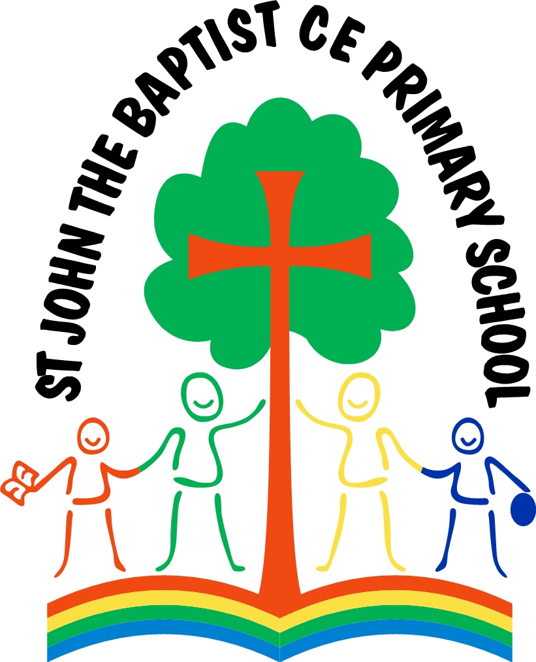

Information

for Parents

Your child could benefit from:

* Exciting new learning activities and opportunities to widen their life experiences
* One to one or small group sessions
* Extra tools, materials and equipment to help with learning in school or at home
* Before/after school clubs or activities

**Here at St Johns, the Pupil Premium money enables;**

* Access to one club per half term.
* Support for training in quality first teaching.
* Financial support for trips and special events.
* Interventions for small group work.
* A book of your child’s choice from the school book fair.
* Support in specific music tutoring.
* Letterbox Parcels for 6 months to support reading and mathematics at home.

**Service Pupil Premium**

Pupils attract SPP if they meet one of the following criteria:

* one of their parents is serving in the regular armed forces.
* one of their parents died whilst serving in the armed forces and the pupil receives a pension under the Armed Forces Compensation Scheme or the War Pensions Scheme

Children have to be flagged as service children ahead of the autumn school census deadline.

Service parents need to make the school aware of their status by talking to the school admin staff.

**Frequently Asked Questions**

**Will the Pupil Premium (PP) affect my benefits?**

No, if your child receives the PP, it will not affect any benefits you may be entitled to.

**How can I ensure the school gets the extra Pupil Premium funding for my child?**

You need to find out first if you can register your child for Free School Meals (FSM). You can do this a few months before your child starts school. It is important to register your child for FSM, even if you are going to send a packed lunch with them every day.

**Does my child automatically qualify for FSM if they have older brothers/sisters in school who are already registered?**

No, you need to register each child.

**I need help to make contact with the Free School Meals team. What do you suggest I do?**

The school office can answer any questions you may have about the PP and FSM. They will be able to support you with the registration process.